pronounced (vi-va-chay)
vivid, lively, full of vivaciousness

Four beautiful voices ~ One glorious sound
Canada’s biggest classical-pop group to emerge since “The Canadian Tenors”

Vivace is a sophisticated and thrilling combination of four exceptional pop and classical singers. Based primarily out of Vancouver, Vivace started merging their talents in 2010, performing at the Vancouver Winter Olympic Games. Since then, they have gone on to tour extensively throughout the United States and Canada, captivating audiences everywhere they go. Members have shared the stage and billed events with artists such as David Foster, Ben Harper, Jackson Browne, Katy Perry, Loverboy, and Colin James, and the group was featured at the TEDxVancouver conference in 2010. Vivace’s stirring combination of male and female voices creates a sound that is exclusively their own, setting them apart in the classical-crossover pantheon. With a rich and diverse repertoire ranging from pop songs, to opera arias, to their own self-written material, Vivace undoubtedly puts a fresh spin on both classical and contemporary music.

Website: vivaceofficial.com
Facebook: facebook.com/officialvivace
Soundcloud: soundcloud.com/vivacemusicgroup
Instagram: @official_vivace
Twitter: @official_vivace

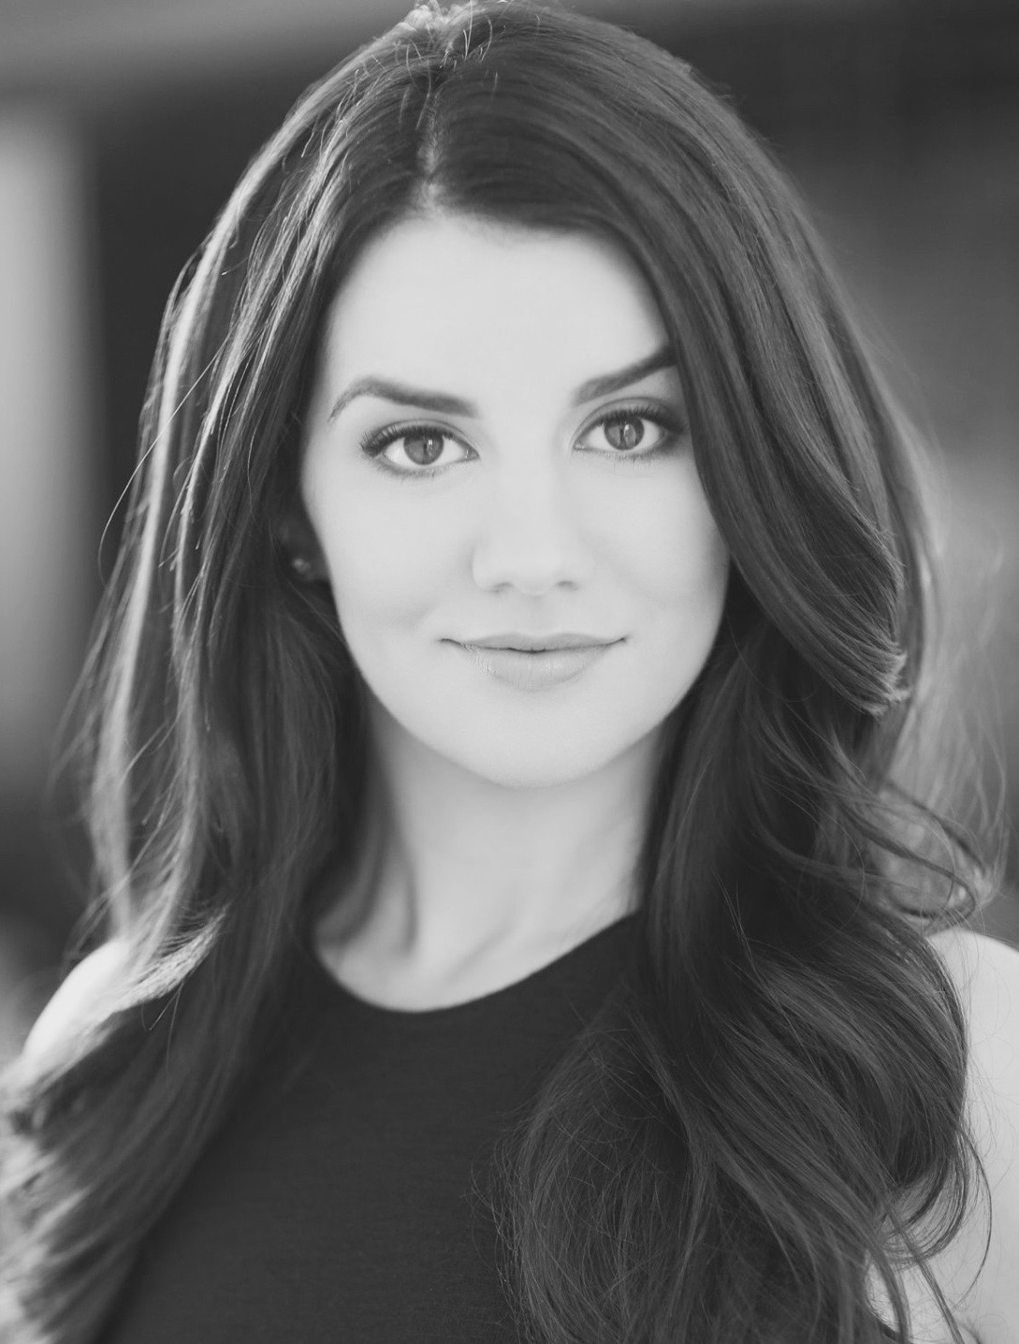
Taylor Pardell

Taylor Pardell is a classically trained soprano and cross-over artist based out of New York City, who has a passion for musical theatre, opera, and jazz. Taylor is grateful to have her voice and performance videos being used as part of the Pre-Show Entertainment for Metallica: WorldWired Tour.
Taylor is a recent graduate of Vancouver Opera’s Yulanda M. Faris Young Artist Program, where she performed the role of Gretel in Hansel and Gretel, La Fée in Cendrillion (Viardot) and Barbarina (Susanna u/s) in Le Nozze di Figaro as part of the inaugural Vancouver Opera Festival. Most recently, Taylor was part of the ensemble in the new musical reading of Michael Strogoff: Courier of the Tsar at the York Theatre in New York City.

Equally at home on the concert stage, Taylor has been a soloist with the Vancouver Symphony Orchestra, the Vancouver Opera Orchestra (Bard on the Beach: Operas & Arias), Opera Kelowna, and the Okanagan Symphony Orchestra, . Her concert repertoire includes Cunegonde (Candide), Frasquita (Carmen) and Musetta (La Bohème), Handel’s Messiah and Mozart’s Mass in C Minor. Recent operatic roles include Gilda (Rigoletto), Olympia (Les contes d’Hoffmann), Gretel (Hansel and Gretel), and the title role in The Cunning Little Vixen/Příhody Lišky Bystroušky in the Czech Republic.

Ms. Pardell has received a M.Mus in Opera Performance from the University of British Columbia, a B.Mus in Voice Performance from the University of Toronto, a Dip.Mus Voice Performance from the Victoria Conservatory of Music and an ARCT Certificate in Voice Performance from the Royal Conservatory of Music.

Taylor is proud to have been a Semi-Finalist in the Lotte Lenya Competition, Winner of the American Protégé Competition, a Finalist at the National Music Festival of Canada and a Canadian representative at the Hans Gabor International Belvedere Singing Competition. Recently, Taylor placed Second in the Voices of Brooklyn Competition.
Taylor is a cantor at St. Augustine’s Church in Park Slope, Brooklyn. She is also a national anthem singer, most notably for the Toronto Blue Jays vs. Boston Red Sox.

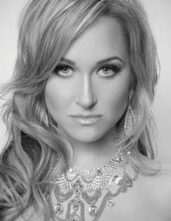
Tiffany Desrosiers
Soprano Tiffany Desrosiers received her Bachelor of Music Degree from the University of British Columbia, with a major in Vocal Performance. Tiffany’s unique ability to sing both pop and classical styles led to occasions to share the stage with David Foster, Ben Harper, Jackson Browne, Colin James, the former Canadian Tenors, Mark Masri, Bobby Kimball (Toto), Jully Black and Loverboy. Tiffany has collaborated as a background vocalist on recordings for Rita MacNeil, Mýa and Melanie B (Spice Girls), and has recorded with Ari Levine of the Smeezingtons, production team and songwriters behind names such as Bruno Mars and Adele. Tiffany performed with role of ‘Köningin der Nacht’ in a 2012 Vancouver Academy of Music production of Mozart’s Die Zauberflöte and most recently headlined the soprano role of Royal Princess Cruises’ production of Encore. On three separate occasions, Tiffany won the BC Provincials, and later went on to represent British Columbia at the Nationals in New Brunswick. Tiffany completed a cross-Canada radio tour of 43 stations in 2015 to promote "Fearless,” a follow-up EP to her 2009 self-titled debut album. Tiffany received funding to complete “Fearless,” which is best described as an infusion of the powerhouse vocals of Celine Dion and Sia, with classical and electronic overtones. Tiffany made her presence known to thousands when she was hand-picked to record and perform the 2010 BC Summer Games Ceremonies theme song. Also in 2010, her club version of When I See You Smile, the classic 1989 power ballad originally recorded by Bad English, reached the top 10 on the UK pop club charts. A multiple finalist of the International Songwriting Competition, American Songwriting Awards and Unsigned Only Competitions, Tiffany recently received acknowledgement for single “Love’s a Losing Game” in the 2016/2017 Canadian Songwriting Competition. Tiffany’s astounding roster of accolades includes special guest performances with 3-time Juno award winning Country Music singer/songwriter Jim Witter in the Spring of 2017 for his “Best of 70’s and 80’s Tour,” and recent performances of “A Tribute to Celine Dion” (produced by Moon Coin Productions).

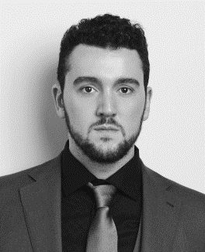
Gabriel Macdonald

Gabriel is the most recent addition to Vivace's vocally talented line up. He has been performing with Vivace since August 2017. Audiences love him and are raving about the rich warmth and depth of his beautiful baritone sound. He is the perfect blend of baritone and tenor, delivering emotional heartfelt performances from beginning to end. Vivace's blend of sound has been taken to the next level with the addition of Gabriel's voice, and we can't wait for you to hear him in person! Gabriel grew up in Nelson B.C. and is from a very musical family, which is where his passion and love for singing began. As a result, he landed his first professional contract at the age of 14.

He resides in Victoria, B.C., which is where he graduated from The Canadian College of Performing Arts with The Founders Award for achievement in musical theatre. As a vocal soloist he has performed the baritone role in Carmina Burana and has performed with the legendary David Foster and the Victoria Symphony Orchestra. Key roles have included ‘Rocky’ in Rocky Horror Picture Show, ’Jesus’ in Jesus Christ Superstar, ‘Trout Stanley’ in Trout Stanley, ‘Cinderella’s Prince’ in Into the Woods, ‘Sweeney Todd’ in Sweeney Todd and ‘Javert’ in Les Miserables. Gabriel has worked with Bluebridge Theatre as a musical director, and pianist for their production of the Canadian classic “Billy Bishop Goes to War” and has worked as a sound designer for several companies in Victoria.

Joel Ros

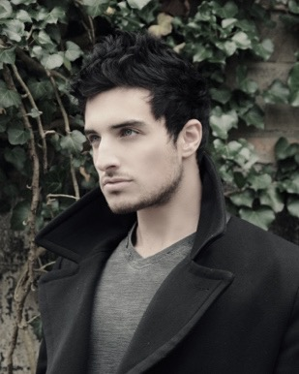
With one of the most beautiful voices to grace the classical crossover genre, Pittsburgh singer-songwriter Joel Ros captures the hearts of audiences with his unique style of pop infused with a classical flair. He trained extensively for over ten years with an SLS private voice instructor and attended performance training courses in Nashville, Tennessee. Joel started singing with internationally acclaimed classical crossover quartet Vivace in the beginning of 2017 and continues to perform with the group as the tenor.

Through his own songwriting, he explores tenants of love, strength, and the courage required to stay true to one's self. This message is apparent in his debut original solo album 11:11, which released in 2017. 11:11 features Joel’s dynamic vocal range as well as a haunting duet with Vivace's own Tiffany Desrosiers.

Throughout his career, Joel has shared the stage with Canadian classical crossover artist Mark Masri, who is known throughout Canada and the US for his outstanding vocals and songwriting, and Joel performed in the opening act for Grammy award winning pop star, Ke$ha in Pittsburgh in 2018. Joel also stars in a brand new show called Evolution that reviews and highlights sixty years of the history of pop music in sixty minutes. When the venues are quiet and the stage lights are off, Joel can be found at the piano for hours at a time crafting new original music. Introduced to songwriting before he was a teenager, Joel has since composed over 100 songs and plans to return to the recording studio in 2019 to begin recording his second original studio album entitled Perfect Love. He is fueled by his passion for music and his love for singing. Between the musical moments, Joel spends much of his time with his horses. He is an accomplished and internationally-known breeder of American Shetland Ponies, and owns one of the largest Natural Hoofcare businesses in the world.

